27.Design Tm using simulator to accept the input string wcw

INPUT:

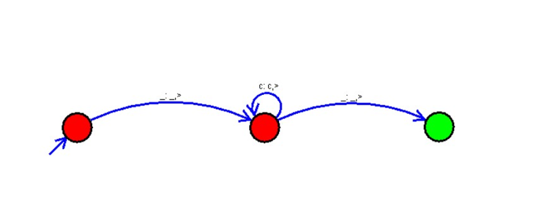

OUTPUT:

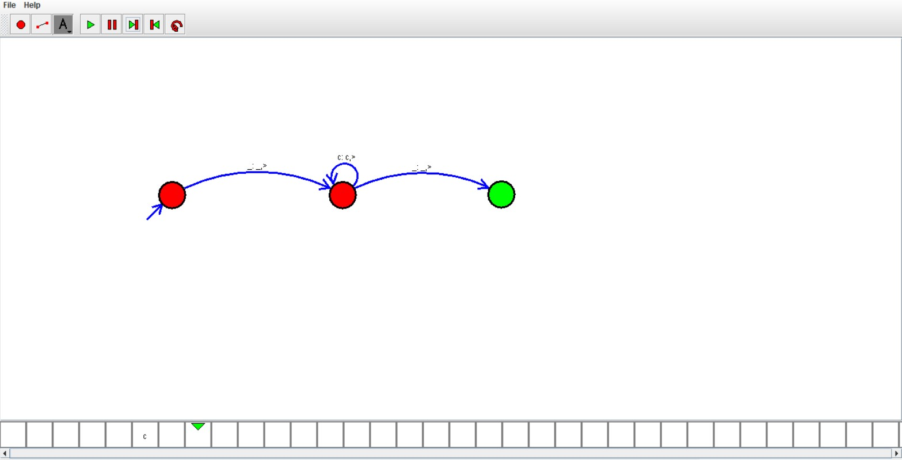

RESULT:

We designed Tm using simulator to accept the input string wcw by using autosim